Experimental study on laser-based micromachining of acrylic plate

|  |  |  |  |
| --- | --- | --- | --- |
| *Submitted by* |  |  |  |
| Gokul V S | 244103219 | Sk Mushraf Parvez | 246103011 |
| Ritwik Jain | 244103208 | B.praveen kumar | 244103203 |
| Mohit Singh | 244103222 | Upendra Sharma | 244103230 |
|  |  |  |  |
|  |  |  |  |

# 1. Introduction:

Laser Beam Micro Machining (LBMM) involves the fabrication of microfeatures with nanometer (nm) tolerances. It utilizes the properties of an ultrashort laser to acquire an exceptional degree of control in generating microfeatures internal to the materials without any collateral damage to the surroundings. The manufacturing industries use LBMM in various fields like micro-optics, micro-electronics, micro-biology, and micro-chemistry. It can fabricate 3-D submicron-sized structures, miniature photonic components, read-only memory chips, hollow channel waveguides used in optical communication networks, optical data memory, and biological optical chips [1].

Lasers are installed widely in everyday life across numerous applications: CD and DVD, barcode scanners, entertainment, welding or cutting in the industry, aid to fire control or alignment of roads and tunnels. In the medical field, lasers are diagnostic and therapeutic instruments offering various solutions. The laser enables greater surgical precision, is less invasive, and promotes healing time or cure. This technique is generally much less traumatic than traditional surgical techniques. The first use of lasers in medicine was to damage the retina and understand ocular injury due to accidental exposure. Several devices have been improved since the first ruby laser, placing ophthalmology at the forefront of medical specialties using this technology. The laser has also many applications in the field of biology. Researchers take the technology to its limits by playing on two main parameters, the short laser pulses—to the femtosecond—and energy beams. Since then, pulsed lasers have become increasingly popular for their ability to ablate biological tissue. For patient diagnosis and experimental studies, biological tissue can be analyzed under a microscope after immuno-histostaining or crushed for further molecular analysis [2].

Laser technology is favored over other methods due to its unparalleled precision, speed, and versatility. Lasers provide exceptional accuracy, enabling intricate cutting, welding, and engraving tasks essential in high-precision industries like electronics and aerospace. They operate at high speeds, significantly enhancing productivity and reducing operational costs. Moreover, lasers are highly versatile, working effectively on various materials, from metals to plastics [3]. Their non-contact process minimizes wear and tear on tools and prevents contamination, ensuring high-quality finishes. The ability to focus laser beams into tiny spots results in minimal waste and excellent energy efficiency. Furthermore, the high degree of control and automation available with laser technology enhances safety and flexibility, making it an indispensable tool in modern manufacturing and numerous other fields.

## 1.1 Types of Lasers used in LBMM

In LBMM, short and ultrashort laser pulses obtained from gas or solid lasers selectively remove material. A laser pulse is called as ultrashort pulse when the thermal diffusion depth (√4at where “a” is the thermal diffusivity and “t” is the diffusion time) is equal to or less than the optical penetration depth. A wide variety of lasers, which provide wavelengths from deep ultraviolet (D-UV) to mid-infrared (M-IR), are used for LBMM. The wavelength conversion of IR laser is possible by passing the light through proper non-linear optical crystals like lithium niobate or beta barium borate. The third and fourth harmonics of laser in the neodymium family i.e. Nd:YAG, Nd: YLF and Nd:YVO4 are in UV range. Table 1 shows some representative lasers in the wavelength range from deep UV to mid-IR which are extensively used for microfabrication applications [1].

Table 1 Types of Laser based on source [2]

|  |  |  |  |  |
| --- | --- | --- | --- | --- |
| **Type of laser** | **Laser material** | **Wavelength** | **Pulse length** | **Frequency** |
| **Solid state laser** | Nd:YAG (second harmonic) | 532 nm | 100-10 ns | 50 Hz |
| Nd:YAG (third harmonic) | 355 nm |  |  |
| Nd:YAG (fourth harmonic) | 266 nm |  |  |
| Nd:YVO | 1064 nm | 2.8 - 7.9 ps | 84 MHz to 77 GHz |
| Nd:GdVO3 | 1053 nm | 37 ps | 100 MHz |
| Nd:BEL | 1070 nm | 2.9-7.5 ps | 250 MHz to 20 GHz |
| Nd:LSB | 1062 nm | 1.6-208 ps | 177-240MHz |
| Nd:glass | 1054" nm " | 7 ps |  |
| Nd:VAN | 750-870" nm " |  |  |
| Nd:YLF | 1047-1053 nm | 1.5-37 ps | 76 MHz to 2.85 GHz |
| Yb:YAG | 1030 nm | 340-730 fs | 35-81MHz |
| Yb:glass | 1025-1082 nm | 58-61 fs | 112 MHz |
| Yb:GdCOB | 1045 nm | 90 fs | 100 MHz |
| Yb:KGW | 1037 nm | 176 fs | 86 MHz |
| Ti:sapphire | 750-880 nm | 6-150 fs | 15 MHz to 2 GHz |
| Cr:LiSAF | 800-880 nm | 12-220 s | 82-200 MHz |
| Cr:LiCAF | 800-820 nm | 20-170 fs | 90-95 MHz |
| Cr:LiSGaF | 830-895 nm | 14-100 fs | 71-119 MHz |
| Cr:LiSCaF | 860 nm | 90 fs | 140 MHz |
| Cr :Forsterite | 1.21-1.29 mum | 14-78 fs | 81-100 MHz |
| Cr:YAG | 1.52 mum | 44 - 120 fs | 81 MHz to 1.2 GHz |
| Fiber lasers | 1064 nm | 100 ns | 20-50 Hz |
| Diode lasers | 0.8 mum |  |  |
| Microchip lasers | 1064 nm | Less than 100 ps | 100 kHz |
|  |  |  |  |  |
| **Gas laser** | ArF | 193 | 5-25 ns | 1-1000 Hz |
| KrF | 248 | 2-60 ns | 1-500Hz |
| XeCl | 308 | 1-250 ns | 1-500Hz |
| XeF | 353 | 0.3-35 | 1-1000Hz |
| CO2 laser | 10,600 | 200 mus | 5Hz |
| Copper vapor lasers | 611-578 | 30 | 4-20Hz |

## 2. Methodology & Experiment

The material removal in LBMM is happen because of laser ablation. Laser ablation is a material removal mechanism by high-intensity laser irradiation resulting from strong laser–material interactions, as shown in Figure 1. Although laser ablation is not used for active-material synthesis, it is a valuable technique for precise cutting and patterning of materials, particularly in the fabrication of WEGs. Metals, semiconductors, ceramics, and polymers can be machined by laser cutting, making laser ablation suitable for machining the layers and components in WEGs, including electrodes, active materials, and packaging layers [4].



Figure :Illustration of interaction between laser and material [1]

The experiment employed a CO2 laser with a scanning velocity ranging from 0.1 mm/s to 250 mm/s and a power range of 9 W to 180 W. Compressed air was continuously supplied at the tip of the laser nozzle to minimize unwanted fire generation. The primary objective of the experiments was to investigate the effects of power and scanning velocity while maintaining a constant distance of 6 mm. The acrylic sheet was positioned on the laser bed, aligned with the origin of the laser cutter's grid, as illustrated in Figure 2. A slot measuring 20 mm was created using the parameters outlined in Table 3.

Table 2 Parameters and corresponding levels

|  |  |  |  |
| --- | --- | --- | --- |
| **Parameter** | **Levels** | | |
| -1 | 0 | 1 |
| **Power (W)** | 40 | 60 | 80 |
| **Scanning velocity (mm/s)** | 70 | 140 | 210 |

Figure Experimental Setup

Table 3 Experimental Parameters

|  |  |  |  |
| --- | --- | --- | --- |
| **Trail No.** | **Power  (%)** | **Scanning velocity  (mm/s)** | **SOD (mm)** |
| 1 | 40 | 70 | 6 |
| 2 | 40 | 140 | 6 |
| 3 | 40 | 210 | 6 |
| 4 | 60 | 70 | 6 |
| 5 | 60 | 140 | 6 |
| 6 | 60 | 210 | 6 |
| 7 | 80 | 70 | 6 |
| 8 | 80 | 140 | 6 |
| 9 | 80 | 210 | 6 |

## 3. Results

The machined acrylic sample is studied for kerf length, laser entry, and exit hole diameter using a microscope (Make: Leica DMC) in the material science lab. The responses are given in Table 4.

**End radius**

**Redepositedmaterial length**

**Length of HAZ**

**Kerf length**

Figure Slot made on the acylic sheet using laser micromachining

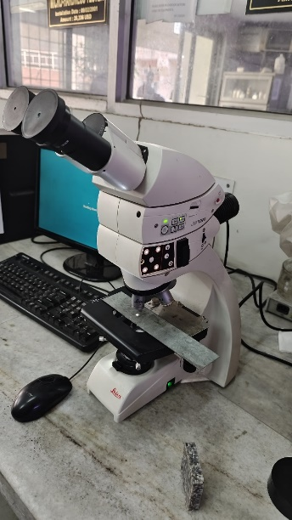 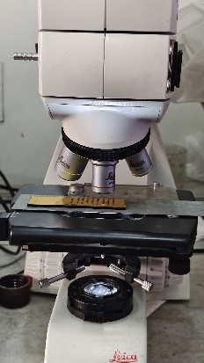

Figure Microscope setup

Table 4 Response table

|  |  |  |  |  |  |
| --- | --- | --- | --- | --- | --- |
| **Power (W)** | **Scanning velocity (mm/s)** | **Average kerf**  **width (mm)** | **Average redeposited**  **material length (mm)** | **Average HAZ (mm)** | **End Radius (mm)** |
| 72 | 70 | 0.430 | 1.001 | 2.080 | 0.181 |
| 72 | 140 | 0.403 | 0.884 | 2.110 | 0.165 |
| 72 | 210 | 0.435 | 0.863 | 1.980 | 0.181 |
| 108 | 70 | 0.473 | 1.030 | 2.253 | 0.258 |
| 108 | 140 | 0.465 | 0.966 | 2.270 | 0.245 |
| 108 | 210 | 0.444 | 0.920 | 2.050 | 0.251 |
| 144 | 70 | 0.477 | 1.058 | 2.330 | 0.255 |
| 144 | 140 | 0.455 | 0.991 | 2.273 | 0.266 |
| 144 | 210 | 0.469 | 0.936 | 2.333 | 0.261 |

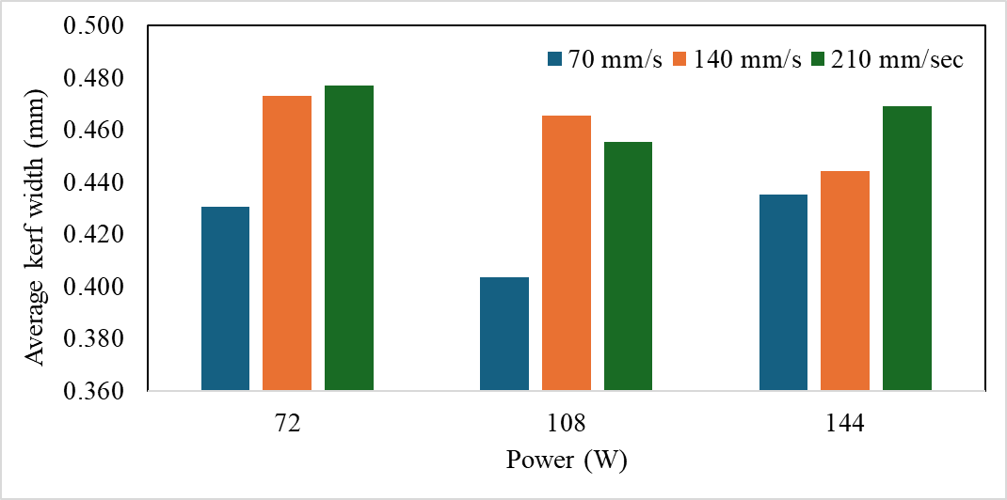

Figure 5: Effect of power and scanning velocity on average kerf width

Figure 5 shows the average kerf width, indicating that as laser power increases, kerf width also tends to expand across all scanning velocity. At 72 W, the kerf width is at its narrowest for the lowest scanning velocity of 70 mm/s and reaches its widest at 140 mm/s. However, as the power increases to 108 W and 144 W, the kerf width increases at all speeds, with 140 mm/s consistently producing a slightly wider kerf than the other speeds. This trend suggests that laser power and scanning velocity influence kerf width, with higher power generally leading to an increase in kerf width, while certain scanning velocity further exacerbates this effect.

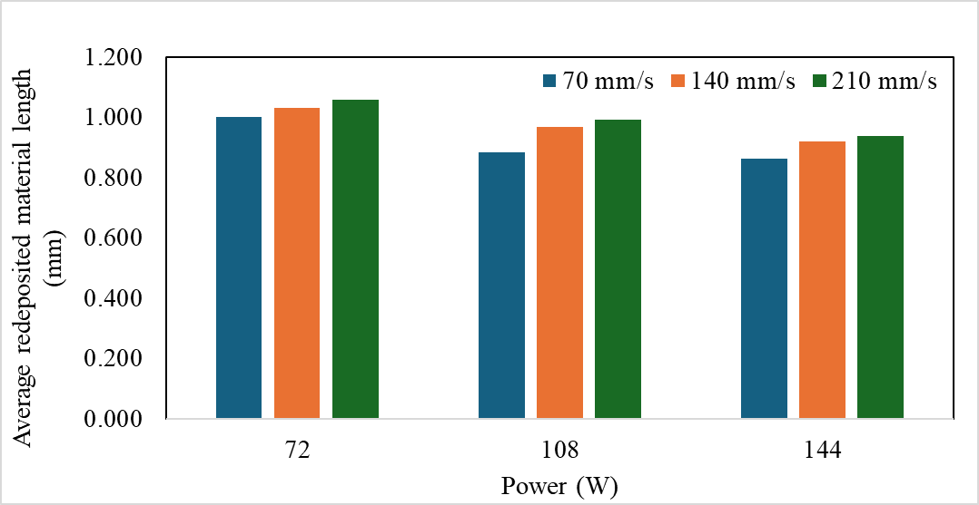

Figure 6: Effect of power and scanning velocity on average redeposited material length

Figure 6 shows the average length of redeposited material, revealing less variation across different power levels and scanning velocities. At 72 W, all scanning velocities produce a redeposited material length close to 1.0 mm, with only minor fluctuations. As the power increases to 108 W and 144 W, this length remains relatively stable, though slight decreases are at higher scanning velocities. This consistency in redeposited material length suggests that laser power and scanning velocity may have a limited impact on this parameter compared to other machining outcomes.

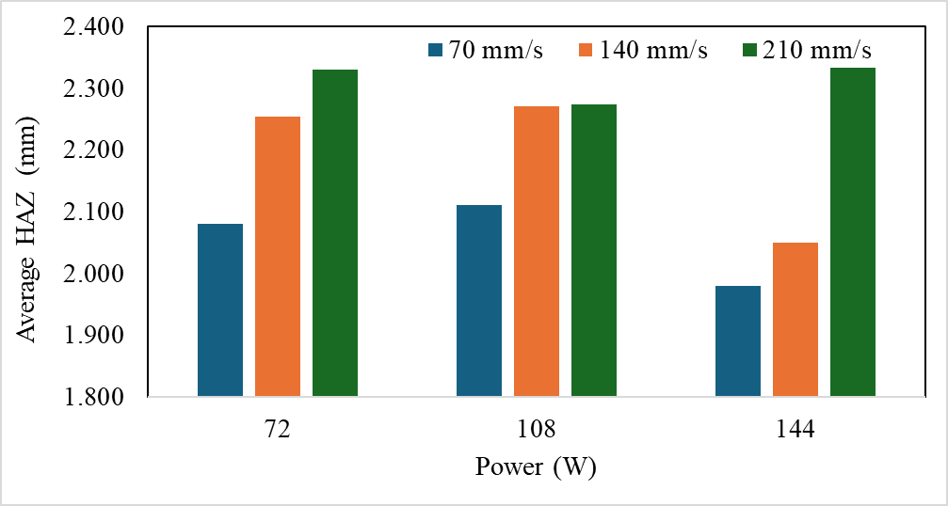

Figure 7: Effect of power and scanning velocity on heat affected zone

Figure 7 shows the average heat-affected zone (HAZ), and it shows at lower scanning velocity, the heat-affected zone decreases as the power increases. At a power level of 72 W, the HAZ is slightly wider at scanning velocity of 140 mm/s and 210 mm/s compared to 70 mm/s. As the power increases to 108 W, there is a marked increase in HAZ width, particularly at the higher scanning velocity of 140 mm/s and 210 mm/s. This trend continues at 144 W, where the HAZ width at 210 mm/s reaches its peak value. These findings indicate that both laser power and scanning velocity significantly influence the HAZ, with higher power and faster speeds generally resulting in a broader HAZ, which may affect the thermal impact on the material.

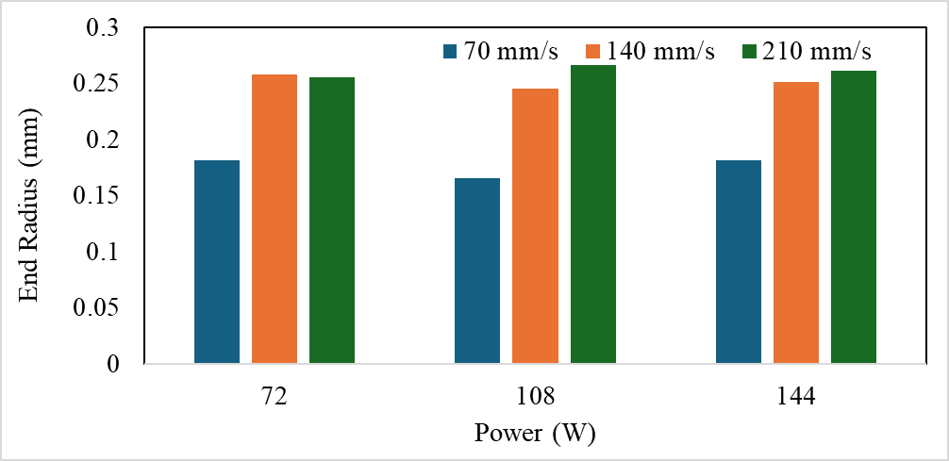

Figure 8: Effect of power and scanning velocity on end radius

Figure 8 shows the end radius, showing that as the scanning velocity increases, the radius at the end of the slot increases. At a power level of 72 W, the end radius is smallest at a scanning velocity of 70 mm/s, while it reaches its maximum at speeds of 140 mm/s and 210 mm/s. As the power increases to 108 W and 144 W, the end radius also rises, with higher scanning velocity resulting in even larger end radii. This indicates that laser power and scanning velocity play a crucial role in determining the size of the end radius, with increased settings leading to a larger radius.

# 4. Conclusion

Based on the result:

* **Average Kerf Width**:
  + As the **power increases** from 72 W to 144 W, it **increases 8% - 13% of** **kerf width** at different scanning velocities.
* **Average Redeposited Material Length**:
  + Changes in laser power and scanning velocity have a limited effect on redeposited material length.
  + The redeposited material length varies by only **3%** across different power levels and scanning velocities, indicating minimal influence from these parameters.
* **Average Heat-Affected Zone (HAZ)**:
  + Increasing power from 72 W to 144 W leads to an **8%–18% increase** in the width of the HAZ, particularly noticeable at higher scanning velocities.
  + At 210 mm/s, the HAZ **decreases by 80%** compared to 70 mm/s when the power is held constant at 108 W, showing that faster scanning velocity decreases the thermal effect.
* **End Radius**:
  + The end radius increases by approximately **40 - 61 %** when power is increased from 72 W to 144 W.
  + Scanning velocity also affects the end radius significantly, with a **10% larger radius** observed at 210 mm/s compared to 70 mm/s for the same power setting.

# References

|  |  |
| --- | --- |
| [1] | V. Y. Sanjay Mishra, "Laser Beam MicroMachining (LBMM) – A review," *Optics and Lasers in Engineering,* pp. 89-122, 2015. |
| [2] | C. C. M. V. A. J. Luc G. Legres, "The Laser Technology: New Trends in Biology and Medicine," *Journal of Modern Physics,* vol. 5, pp. 267-279, 2014. |
| [3] | A. K. Maini, Lasers and Optoelectronics, John Wiley and Sons Ltd, 2013. |
| [4] | X. Z. L. Z. Daozhi Shen, "Laser processing for electricity generators: Physics, methods and applications," *Nano Energy,* vol. 120, 2024. |